**Name**: Khushei Meghana Meda

**SRN**: PES1201800416

**Week number**: 1

**Name of experiment**: Learn and Understand Network Tools

**Date**: 05-09-2020

**Objectives of the experiment**: Study and understand the basic networking tools - Wireshark, Tcpdump, Ping, Traceroute.

**Task1**: **Linux Interface Configuration (ifconfig / IP command)**

Step 1: To display status of all active network interfaces

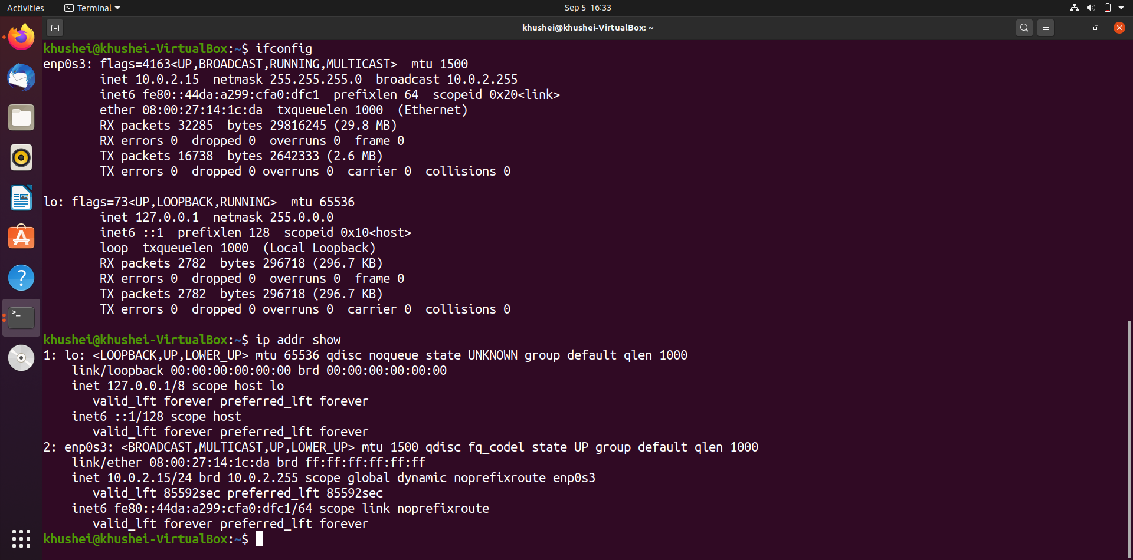

|  |  |  |
| --- | --- | --- |
| **Interface Name** | **IP Address** | **MAC Address** |
| lo | 127.0.0.1 | 00:00:00:00:00:00 |
| enp0s3 | fe80::44da:a299:cfa0:dfc1 | 08:00:27:14:1c:da |

Step 2: To assign an IP address to an interface, use the following command

Ifconfig is executed again to verify the changes have taken effect.

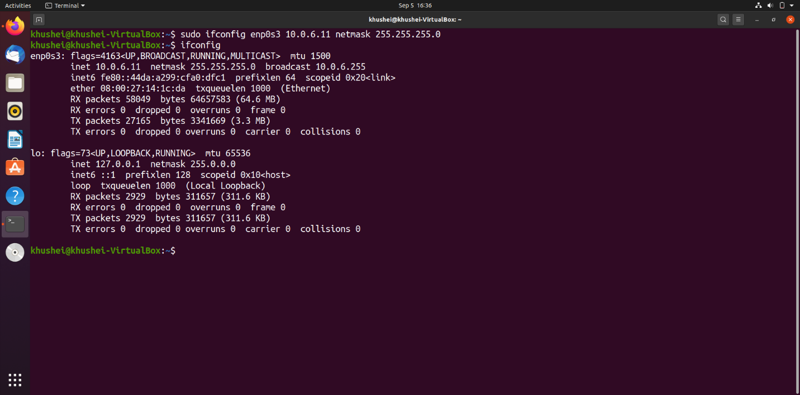

Step 3: To activate / deactivate a network interface, type.

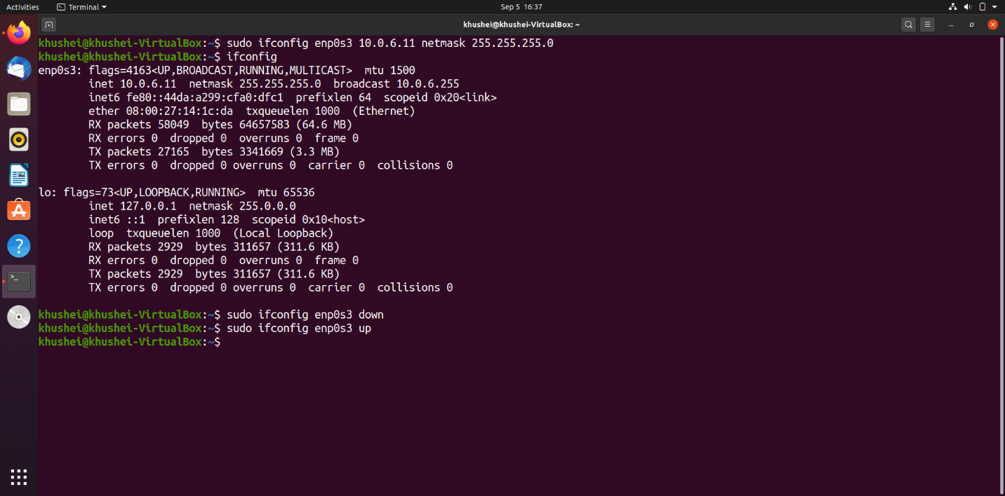

Step 4: To show the current neighbor table in kernel, type

Before executing ip neigh, we execute ifconfig and see that it the IP address has gone back to the original 10.0.2.15 from 10.0.6.11 for enp0s3 interface. I have left it as it is so that ip neigh shows me the current neighbor table while I am connected to the internet. If the IP address were set manually through GUI in step 3, it would have persisted as 10.0.6.11 and in that case we would not get any output for ip neigh as it would not be connected to the internet.

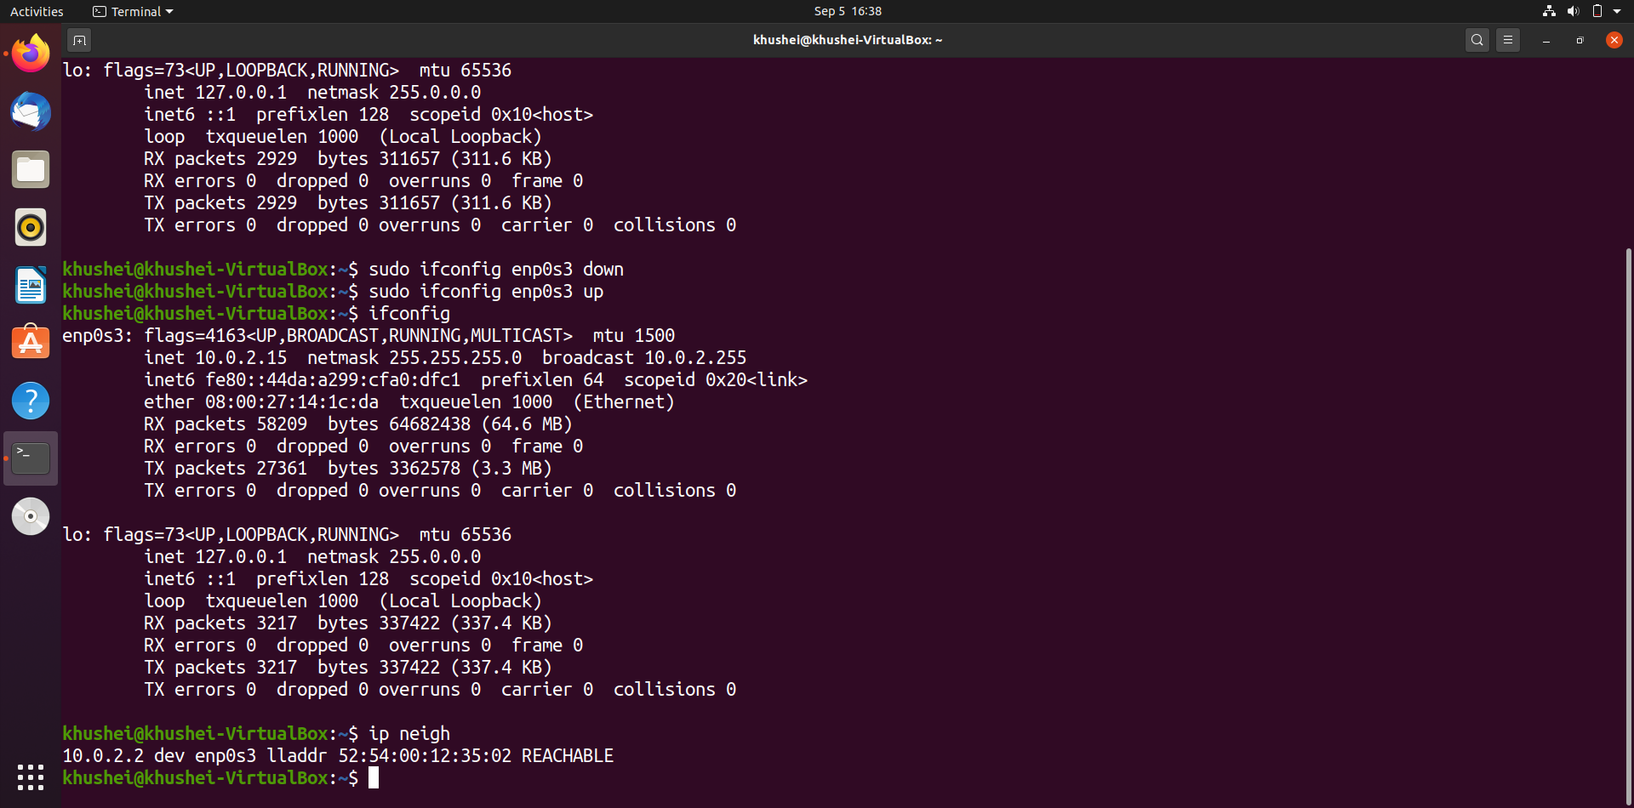

**Task 2**: **Ping PDU (Packet Data Units or Packets) Capture**

Step 1:Assign an IP address to the system (Host).

We start by checking the current ip address of the host by executing hostname -i command and find it to be 127.0.1.1. So I now change it to 10.0.6.11

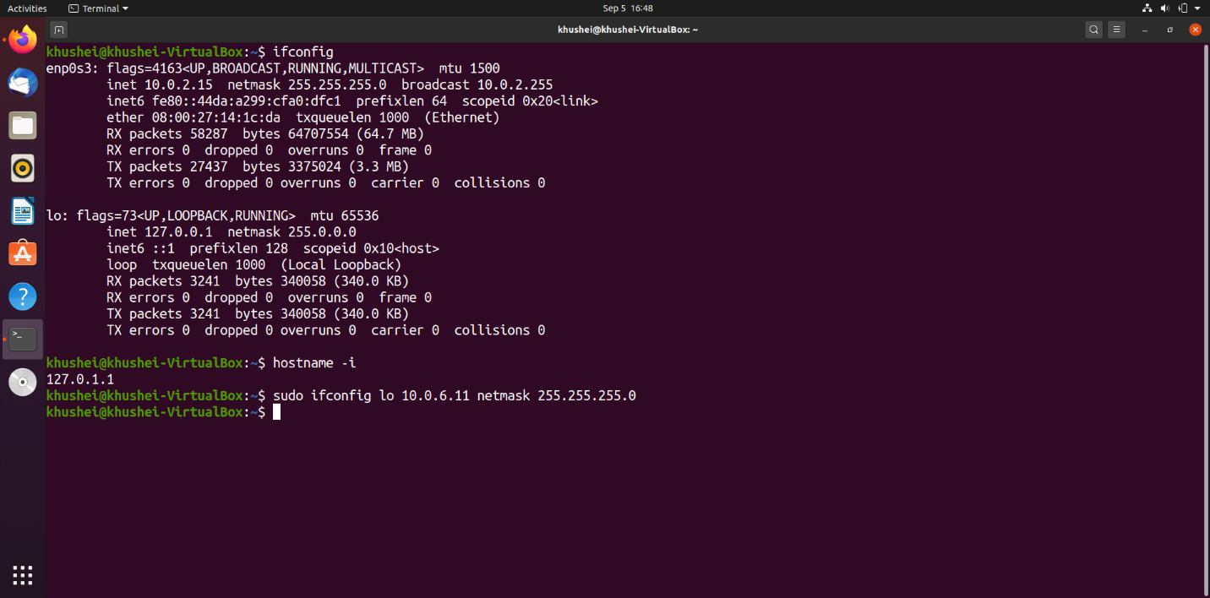

Step 2: Launch Wireshark and select ‘any’ interface

Step 3: In terminal, type **ping 10.0.your_section.your_sno**

Launch wireshark with superuser privileges to find the ‘any’ interface option

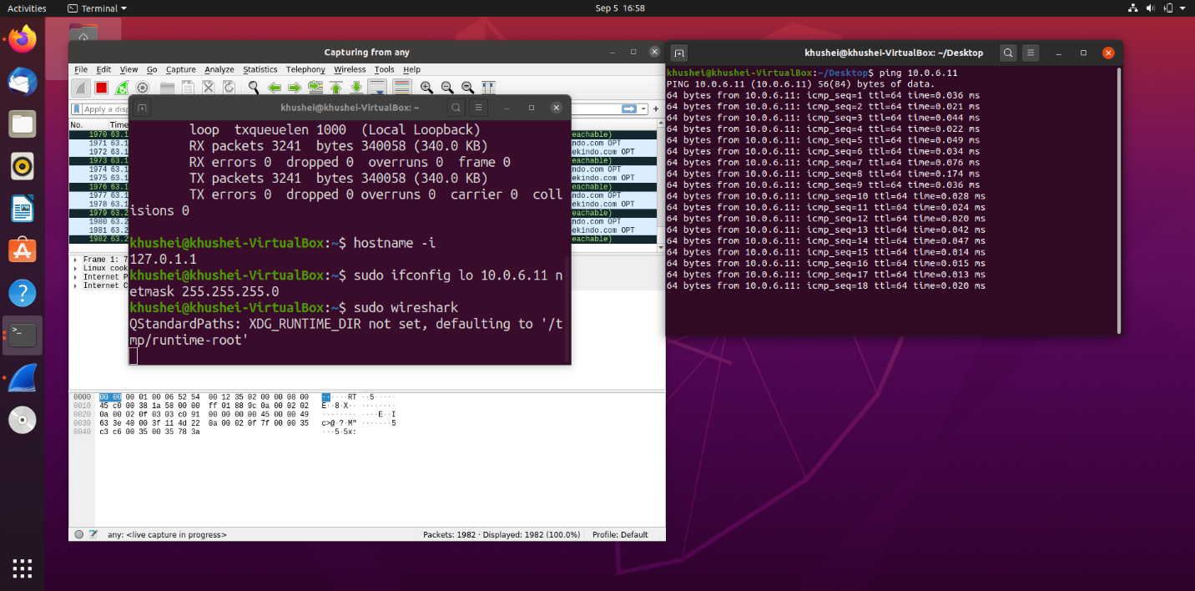

Step 4:Analyze the following in Terminal

• TTL • Protocol used by ping • Time

Observations:

TTL: 64

Protocol: ICMP

Time for transmission and reception of 32 packets: 31722 ms

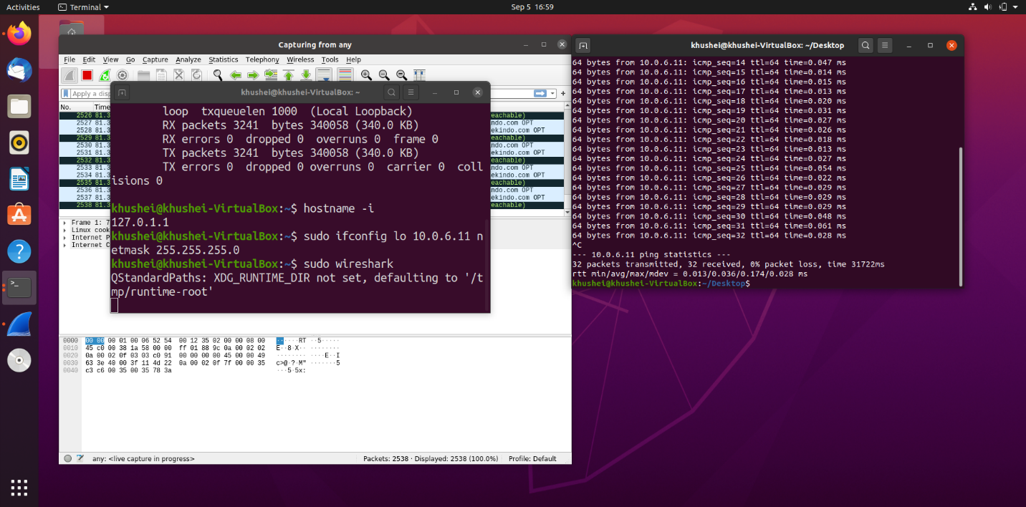

Step 5: Analyze the following in Wireshark

|  |  |  |
| --- | --- | --- |
|  | **First Echo Request** | **First Echo Reply** |
| **Frame Number** | 1381 | 1382 |
| **Source IP address** | 10.0.6.11 | 10.0.6.11 |
| **Destination IP address** | 10.0.6.11 | 10.0.6.11 |
| **ICMP Type Value** | 8 | 0 |
| **ICMP Code Value** | 0 | 0 |
| **Source Ethernet Address** | 00:00:00_00:00:00 | 00:00:00_00:00:00 |
| **Destination Ethernet Address** | 00:00:00_00:00:00 | 00:00:00_00:00:00 |
| **Internet Protocol Version** | 4 | 4 |
| **Time To Live (TTL) Value** | 64 | 64 |

First echo request (all the information has been expanded in the following screenshots):

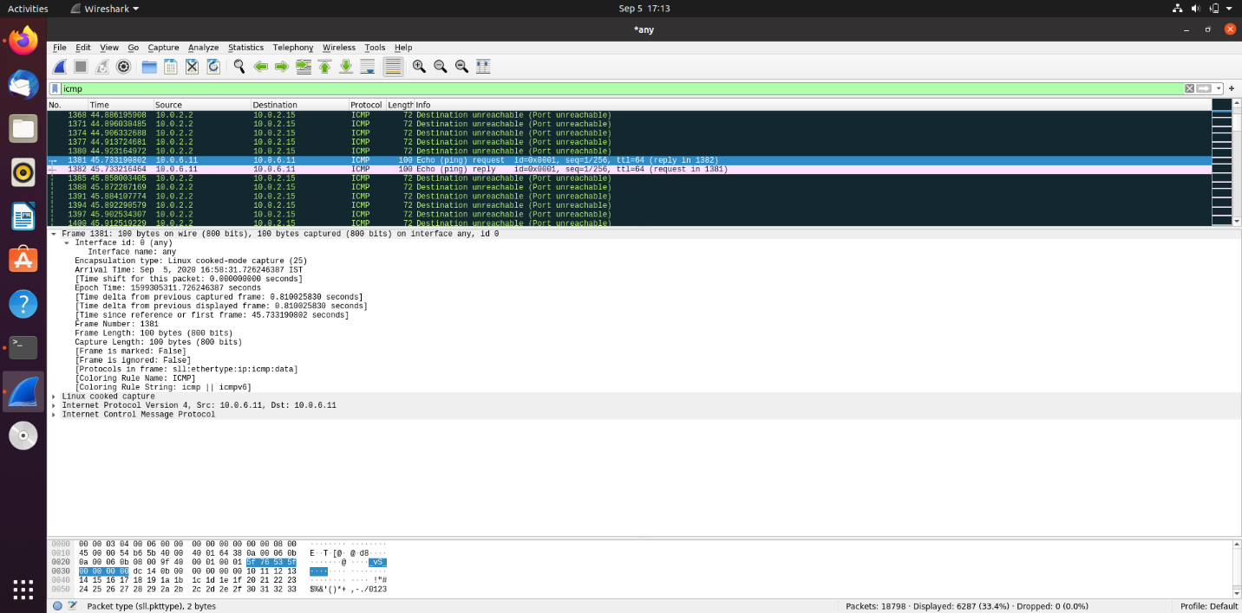

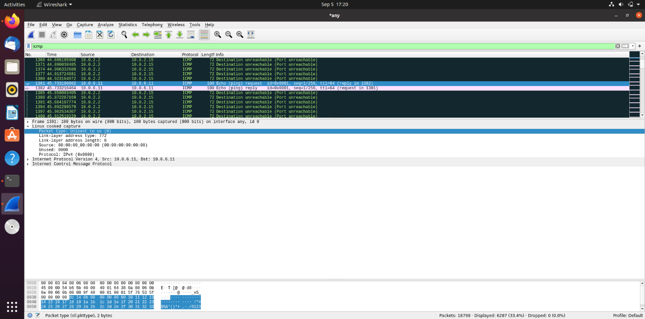 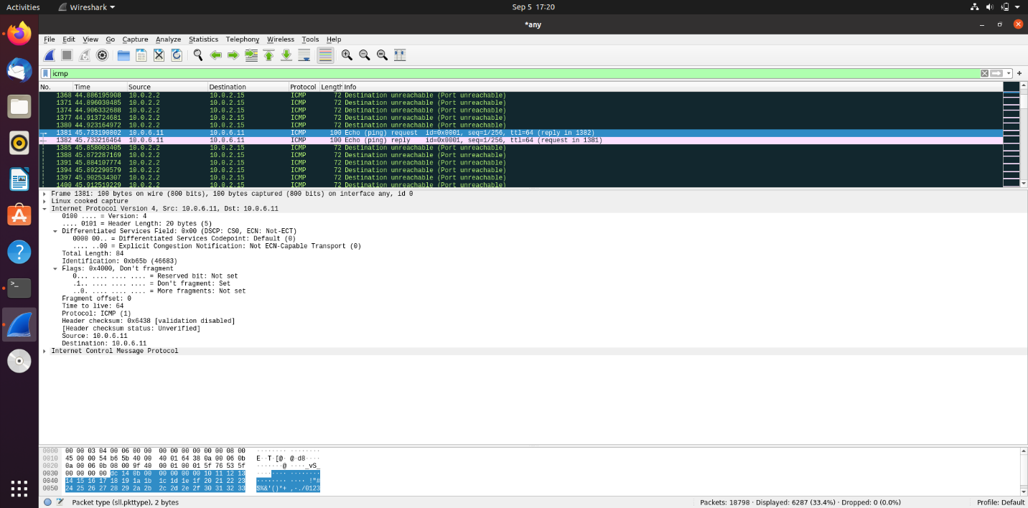

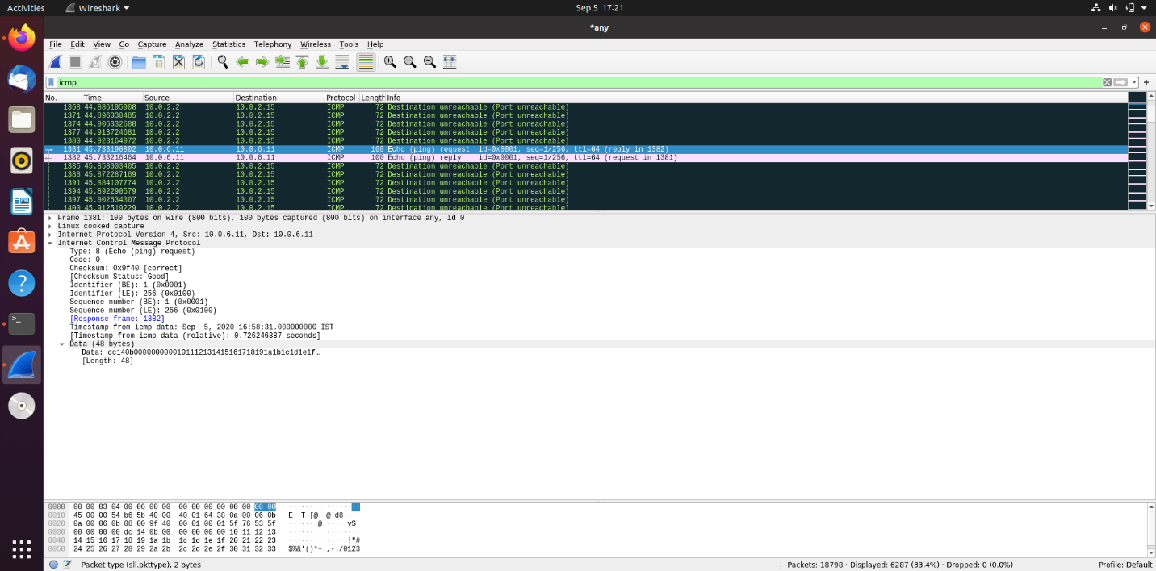

First echo response (all the information has been expanded in the following screenshots):

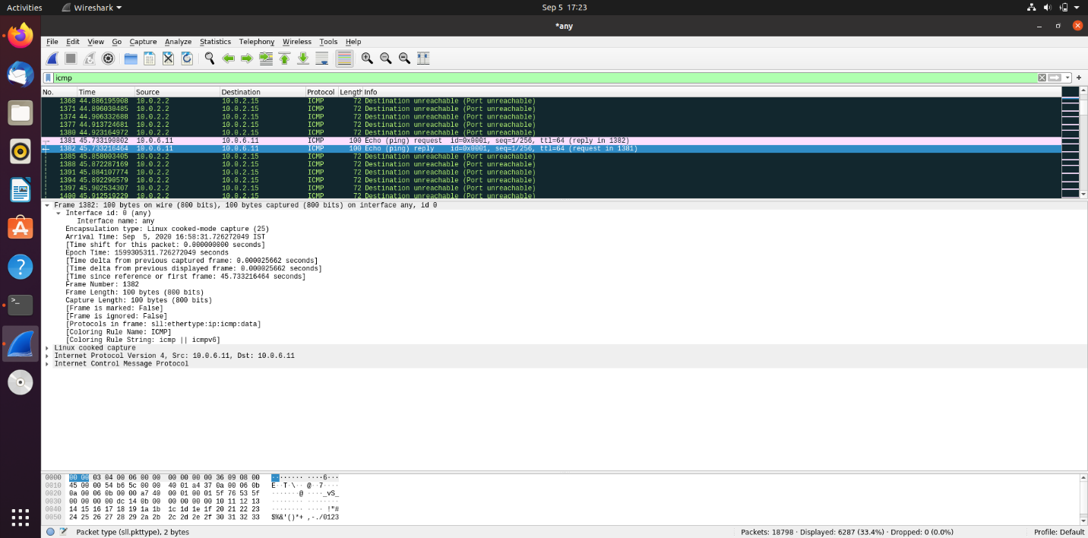

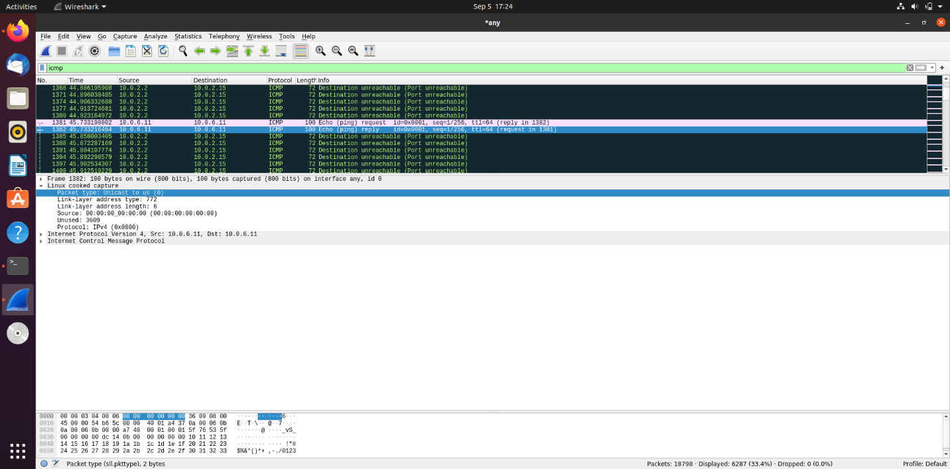

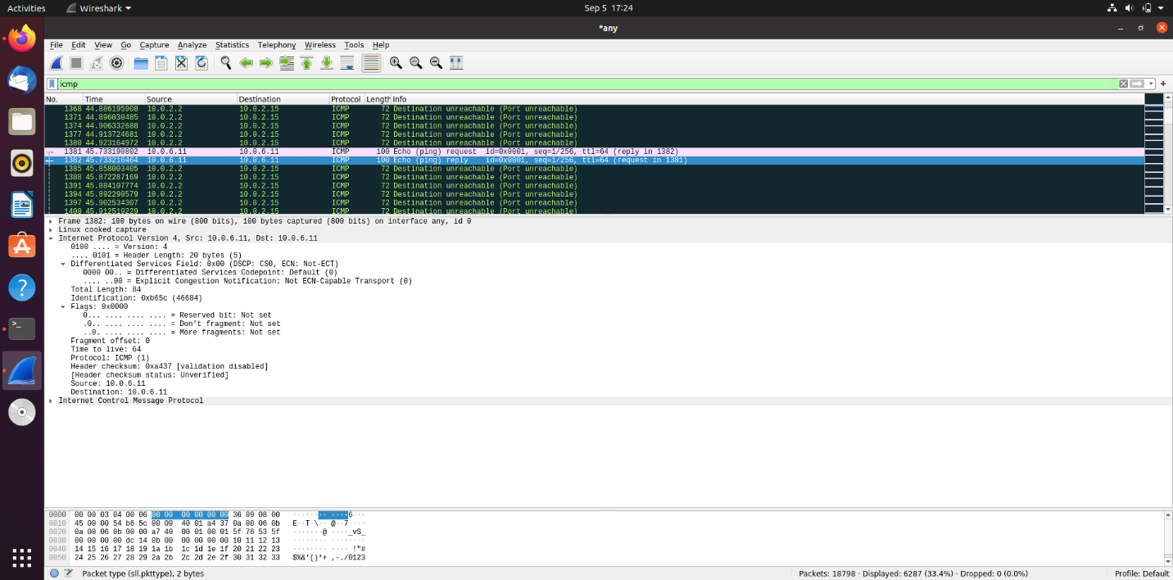

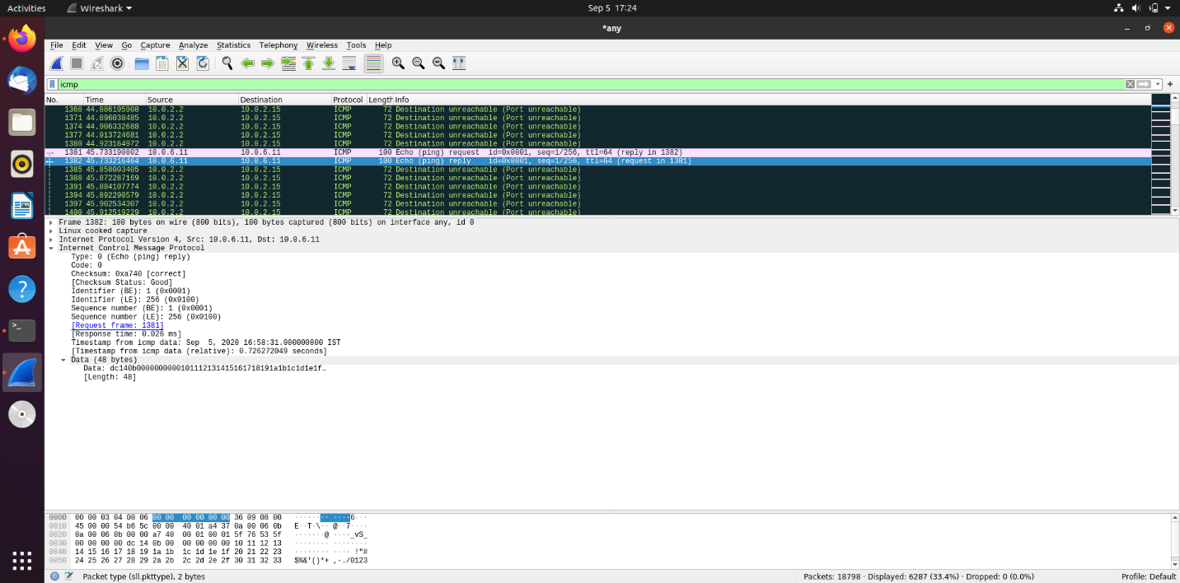

**Task 3**: HTTP PDU Capture

**Using Wireshark’s Filter feature**

Step 1:Launch Wireshark and select ‘any’ interface. On the Filter toolbar, type-in ‘http’ and press enter

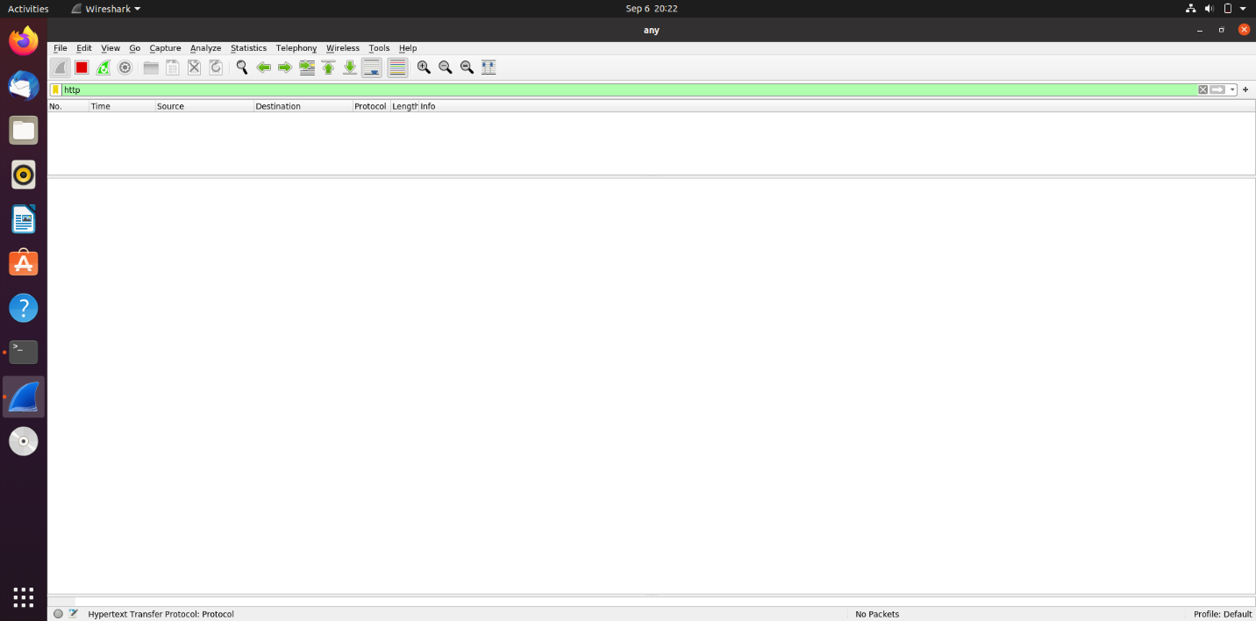

Step 2: Open Firefox browser, and browse www.nyu.edu

|  |  |  |
| --- | --- | --- |
| **Details** | **First Echo Request** | **First Echo Reply** |
| Frame Number | 181 | 182 |
| Source Port | 60558 | 80 |
| Destination Port | 80 | 60558 |
| Source IP address | 10.0.2.15 | 117.18.237.29 |
| Destination IP address | 117.18.237.29 | 10.0.2.15 |
| Source Ethernet Address | 08:00:27:14:1c:da | 52:54:00:12:35:00 |
| Destination Ethernet Address | 52:54:00:12:35:00 | 08:00:27:14:1c:da |

First echo request (the required information has been expanded in the following screenshots):

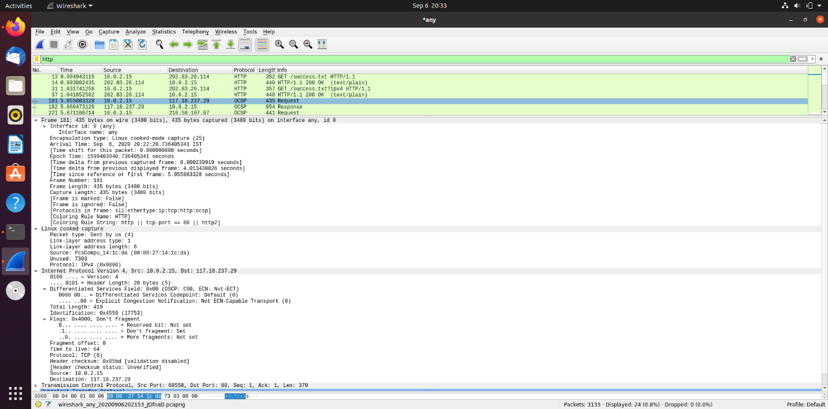

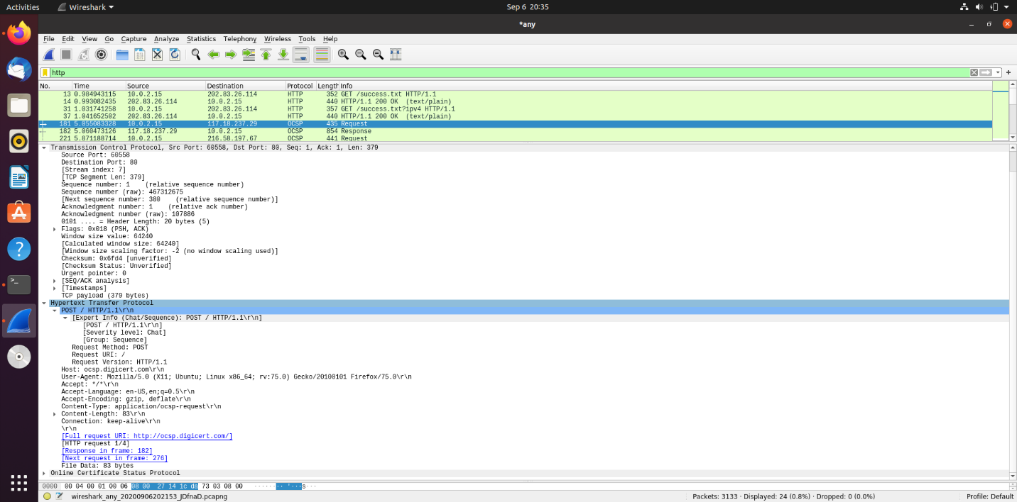

First echo response (the required information has been expanded in the following screenshots):

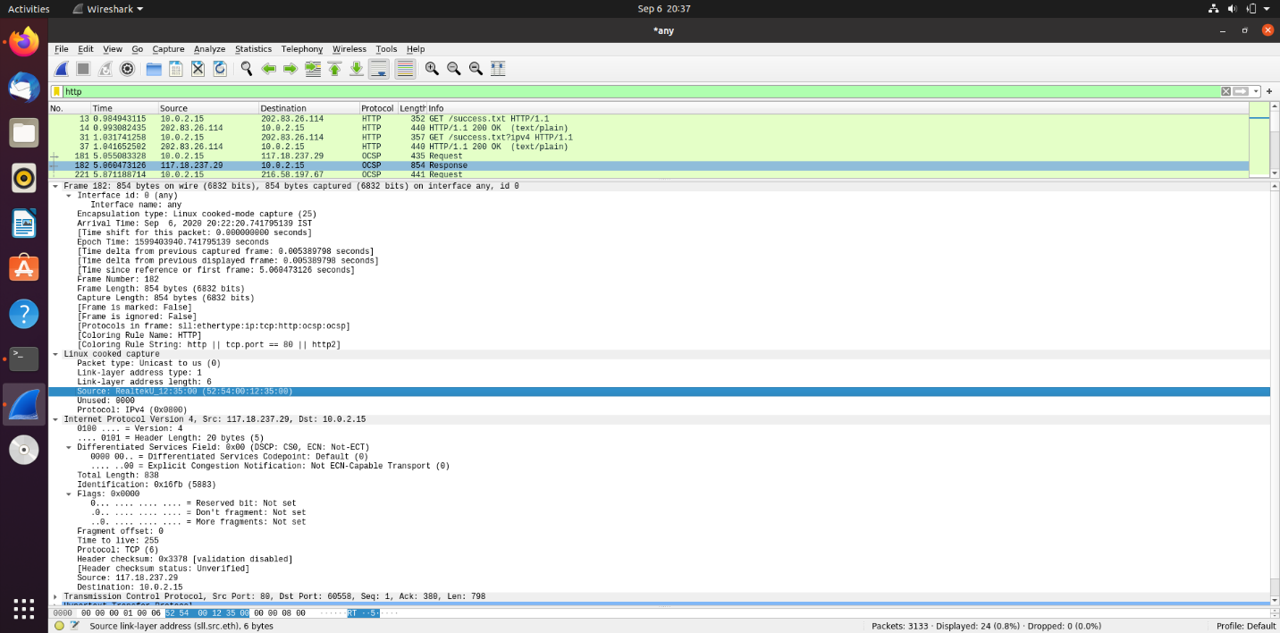

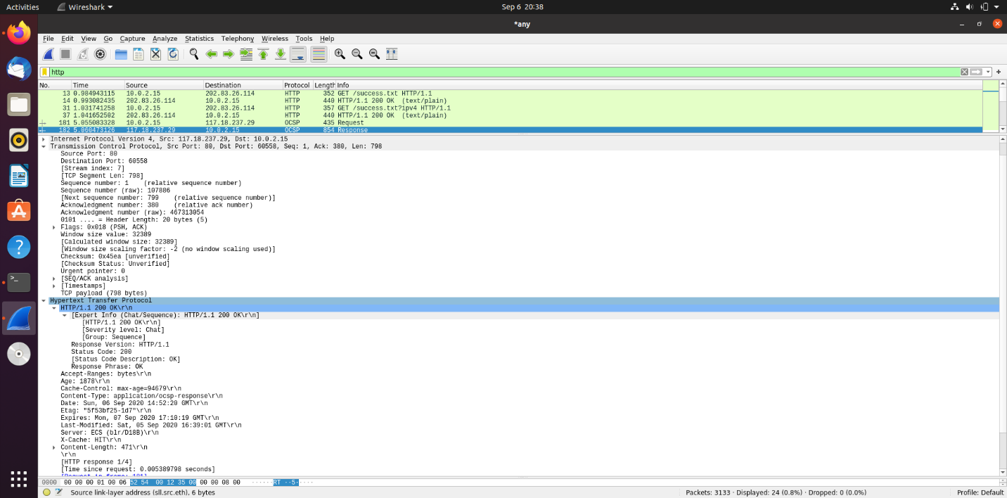

Step 4: Analyze the HTTP request and response and complete the table below.

|  |  |  |  |
| --- | --- | --- | --- |
| **HTTP Request** |  | **HTTP Response** |  |
| Get | GET /success.txt HTTP/1.1\r\n | Server | AmazonS3 |
| Host | detectportal.firefox.com\r\n | Content-Type | text/plain |
| User-Agent | Mozilla/5.0 (X11; Ubuntu; Linux x86_64; rv:75.0) Gecko/20100101 Firefox/75.0 | Date | Sun, 06 Sep 2020 14:52:16 GMT |
| Accept-Language | en-US,en;q=0.5 | Location | *N/A* |
| Accept-Encoding | gzip, deflate | Content-Length | 8\r\n |
| Connection | keep-alive\r\n | Connection | keep-alive\r\n |

HTTP request:

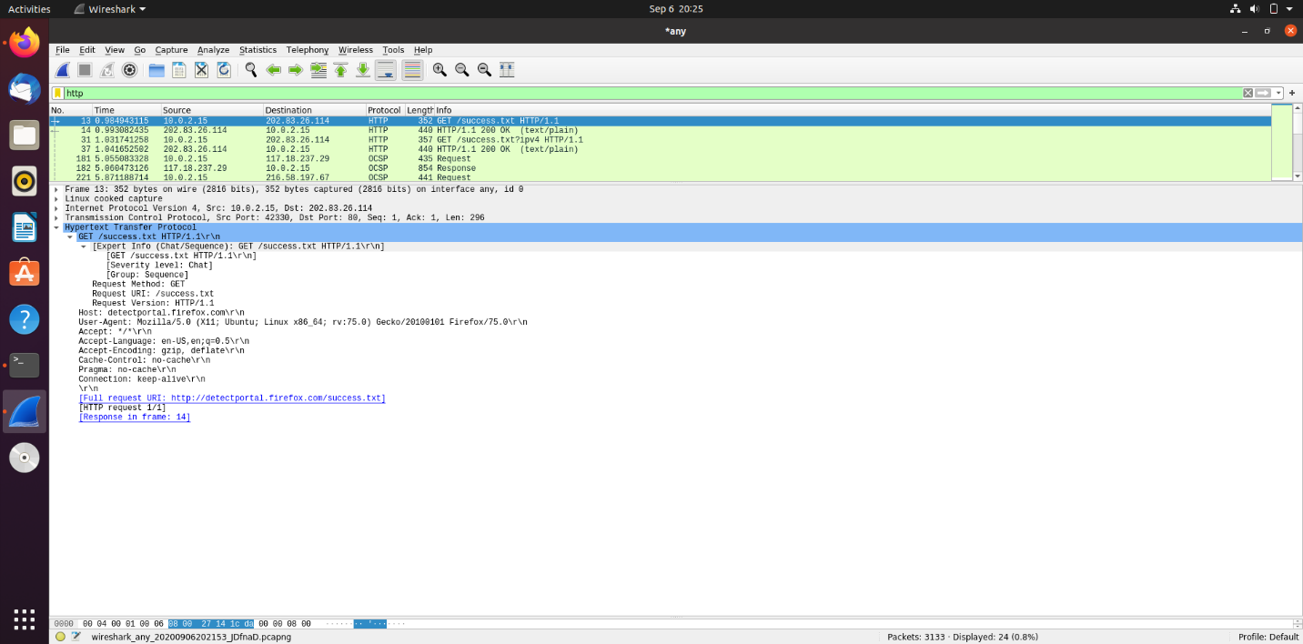

HTTP response (all the information has been expanded in the following screenshots):

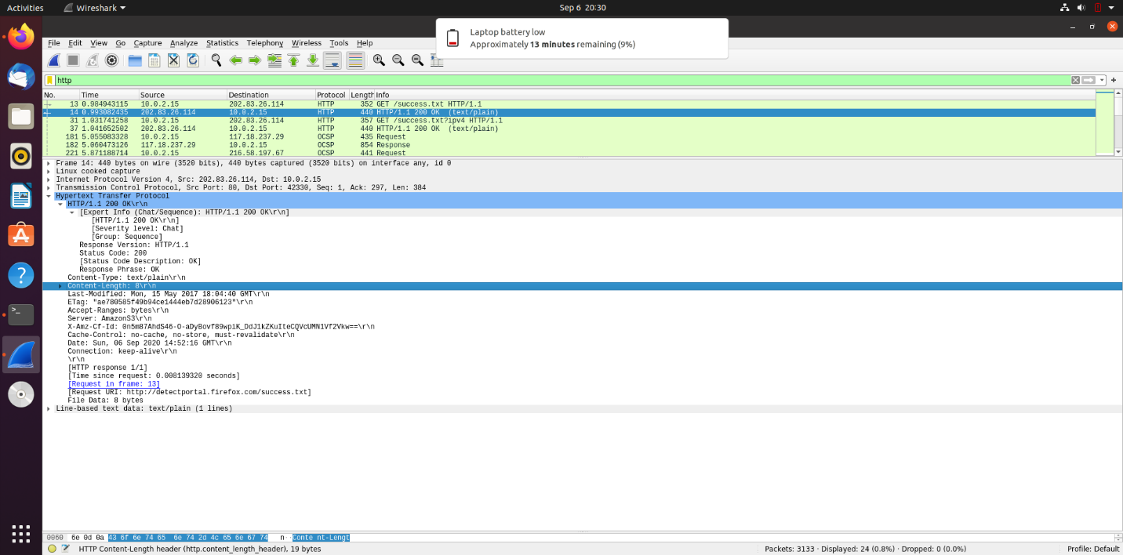

**Using Wireshark’s Follow TCP Stream**

Step 1:Make sure the filter is blank. Right-click any packet inside the Packet List Pane, then select ‘Follow TCP Stream’. For demo purpose, a packet containing the HTTP GET request “GET / HTTP / 1.1” can be selected.

Step 2: Upon following a TCP stream, screenshot the whole window.

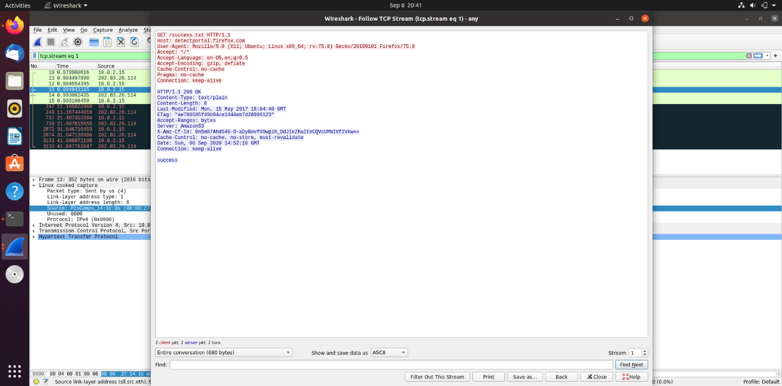

**Task 4**: Capturing packets with tcpdump

Step 1:Use the command **tcpdump -D** to see which interfaces are available for capture.

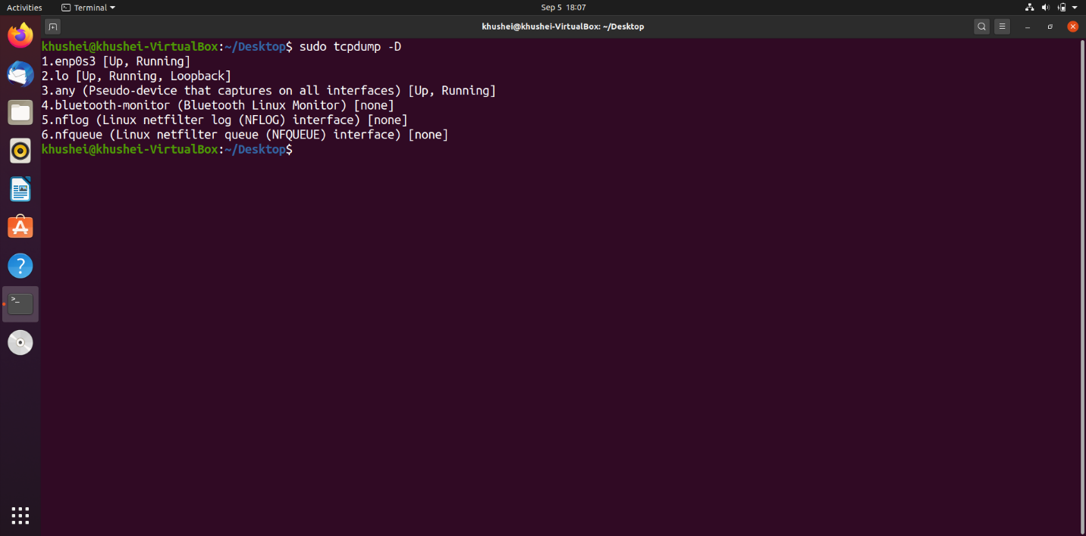

Step 2: Capture all packets in any interface by running this command

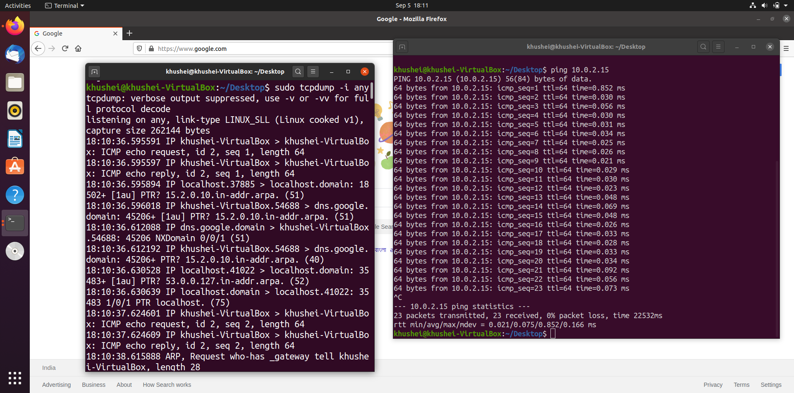

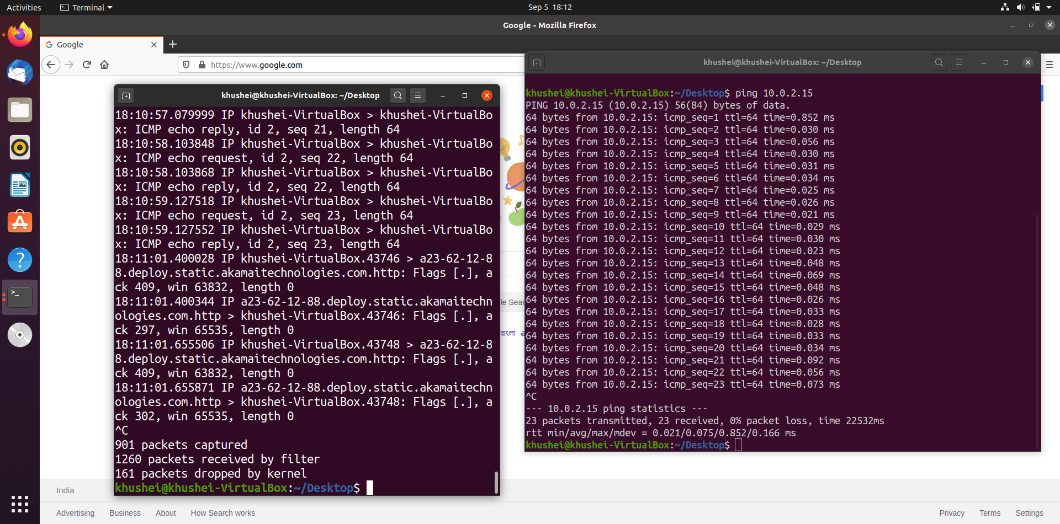

Step 3: Understand the output format.

Each line begins with a timestamp. That is followed by the network layer protocol IP. Then we get the source IP and port, a ‘>’ symbol and then the destination IP and port. After this we get a flag indicating the type of interchange. Then there is an acknowledgement number representing the byte to be sent or received. Following this is win and a number that represents the size available in the receiving buffer. After this finally is the packet length.

Step 4:To filter packets based on protocol, specifying the protocol in the command line. For example, capture ICMP packets only by using this command:

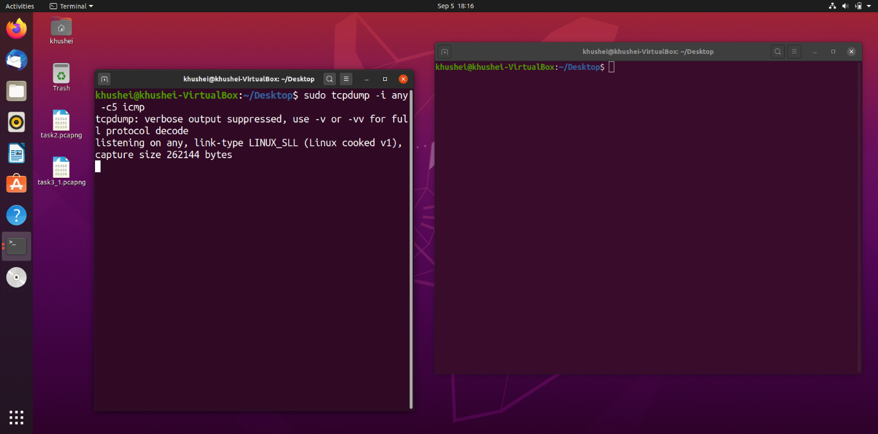

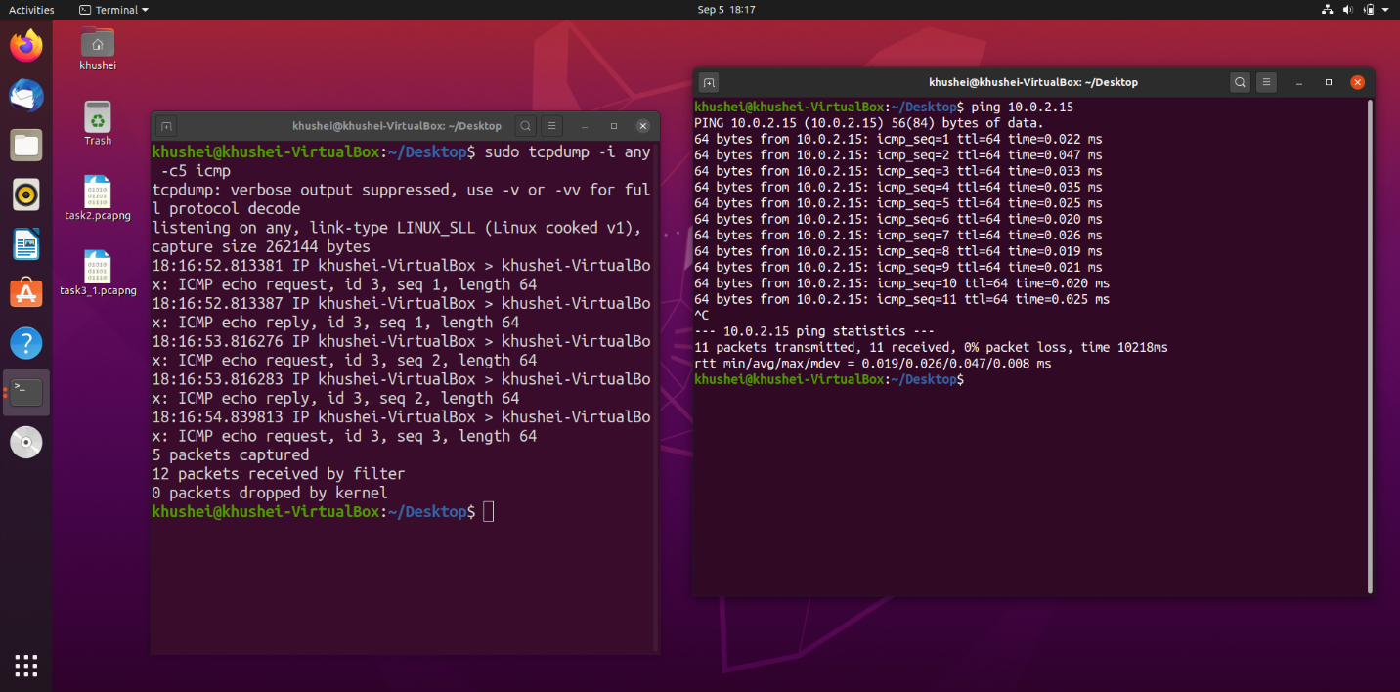

Step 5:Check the packet content. For example, inspect the HTTP content of a web request:

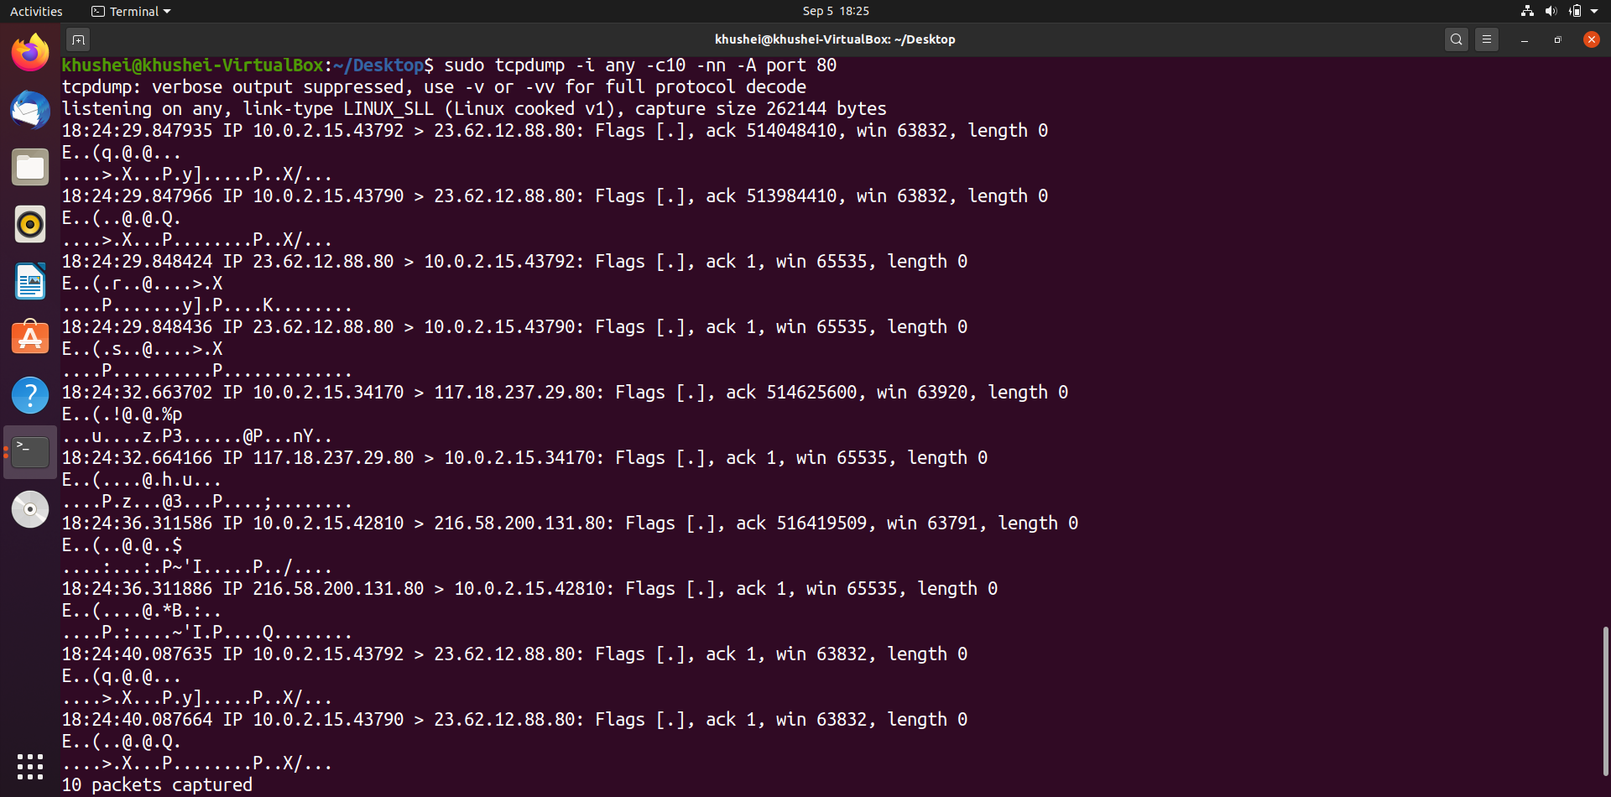

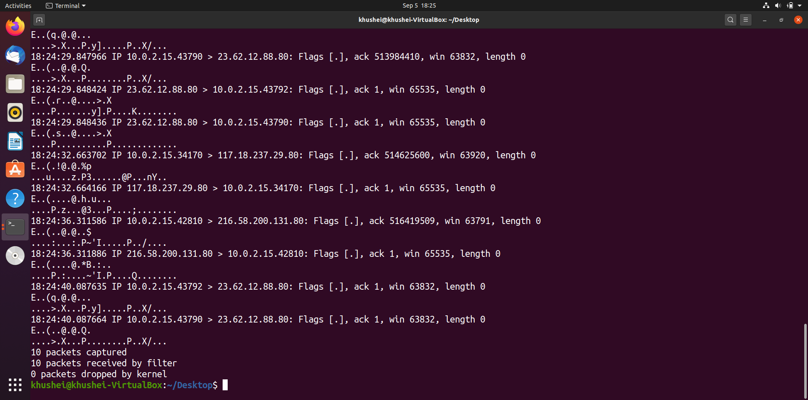

**Step 6:** To save packets to a file instead of displaying them on screen, use the option -w:

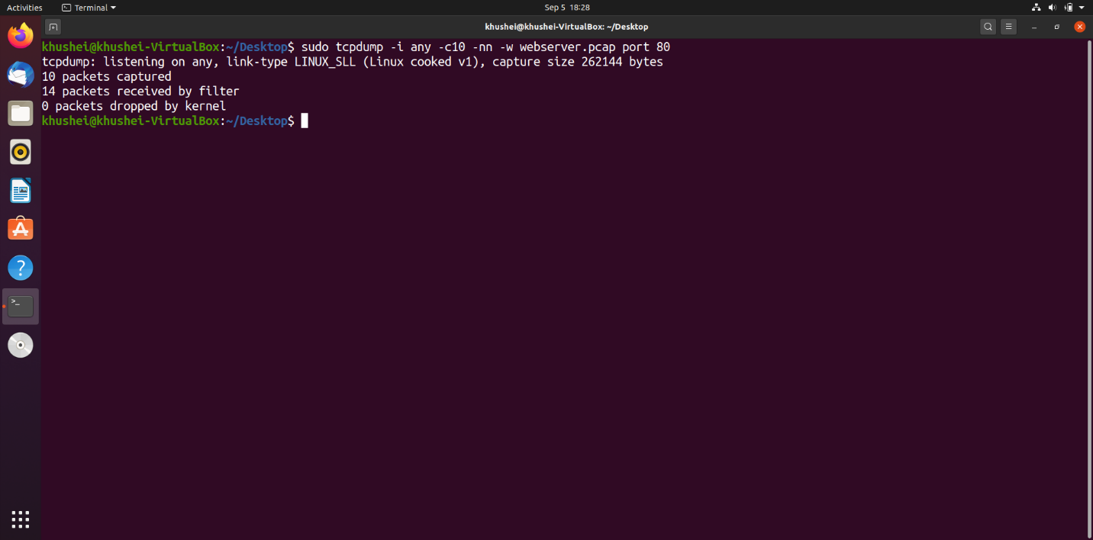

The wireshark file-

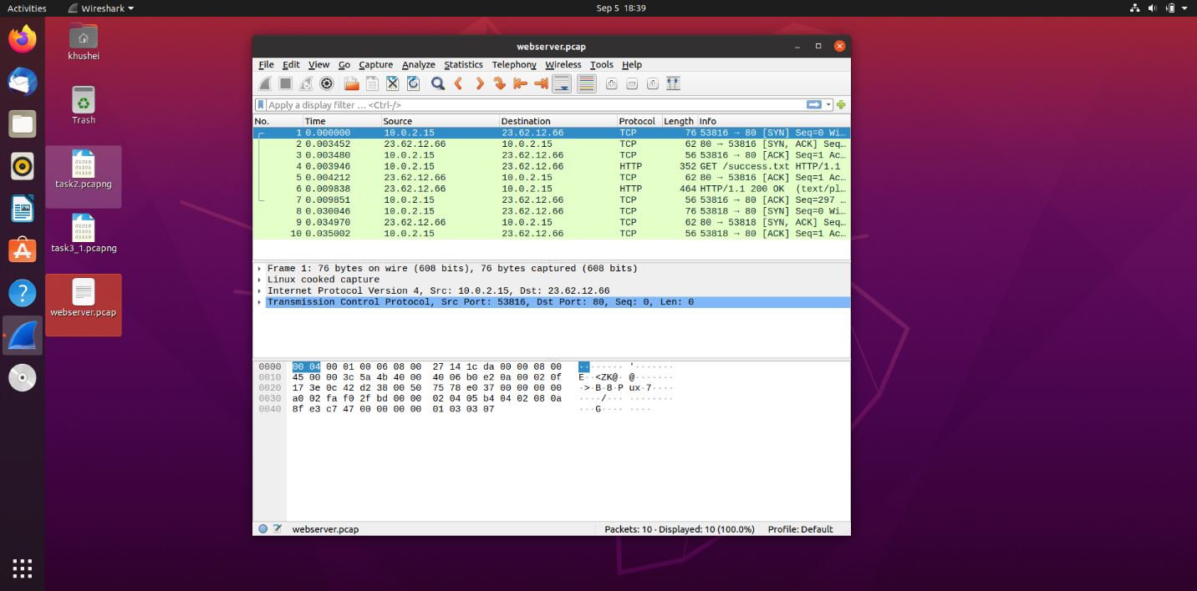

**Task 5**: Perform Traceroute checks

Step 1: Run the traceroute using the following command.

Traceroute was not installed in my Ubuntu VM, so I installed it with sudo apt-get install traceroute and then executed the given command.

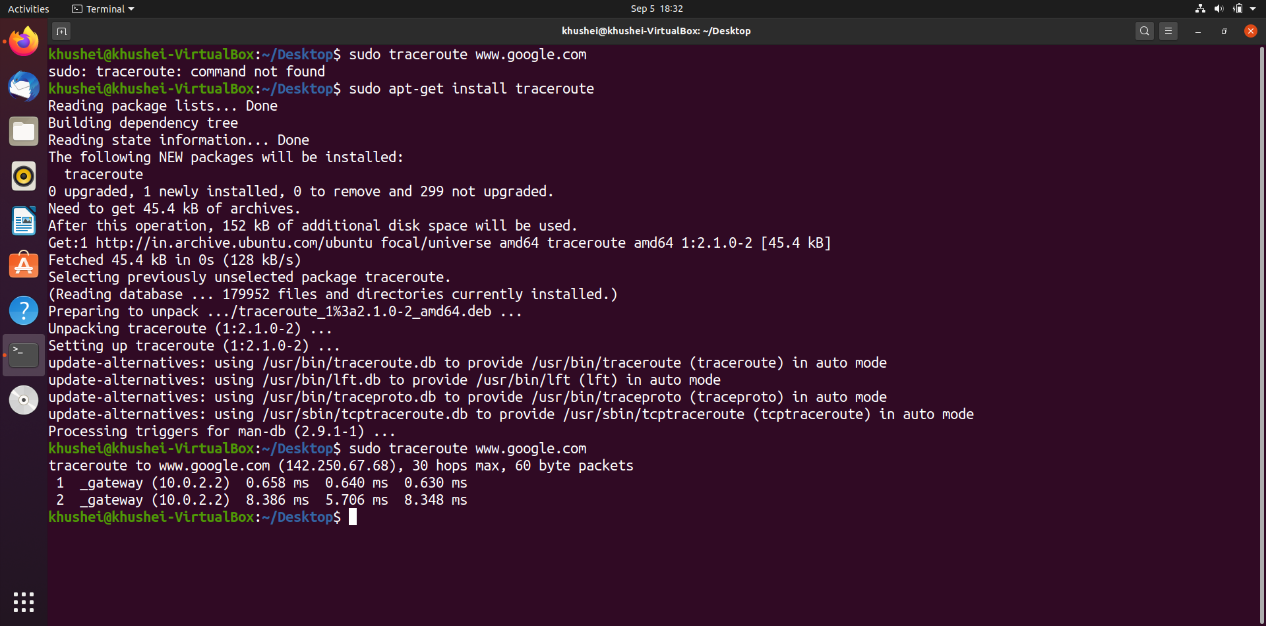

Step 2: Analyze destination address of google.com and no. of hops

Observation: Destination IP address is 142.250.67.68 and number of hops are 2

Step 3: To speed up the process, you can disable the mapping of IP addresses with hostnames by using the *-n* option

Step 4: The -I option is necessary so that the traceroute uses ICMP.

Step 5:By default, traceroute uses icmp (ping) packets. If you’d rather test a TCP connection to gather data more relevant to web server, you can use the -T flag.

(Step 3,4,5 are all shown in the below screenshot)

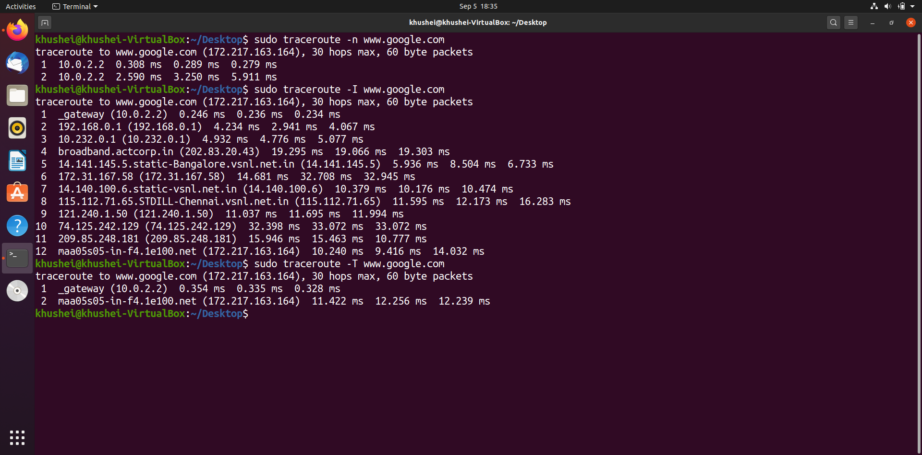

**Task 6:** Explore an entire network for information (Nmap)

Step 1: You can scan a host using its host name or IP address, for instance.

Step 2:Alternatively, use an IP address to scan.

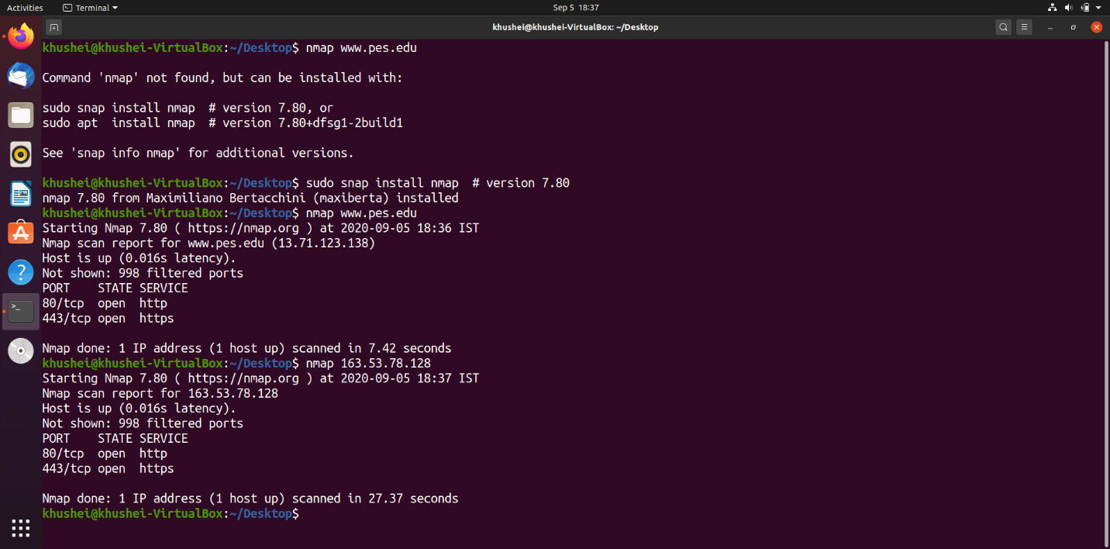

Step 3:Scan multiple IP address or subnet (IPv4)

The output shows 0 hosts up because neither of these three IP addresses are up and running in our network.

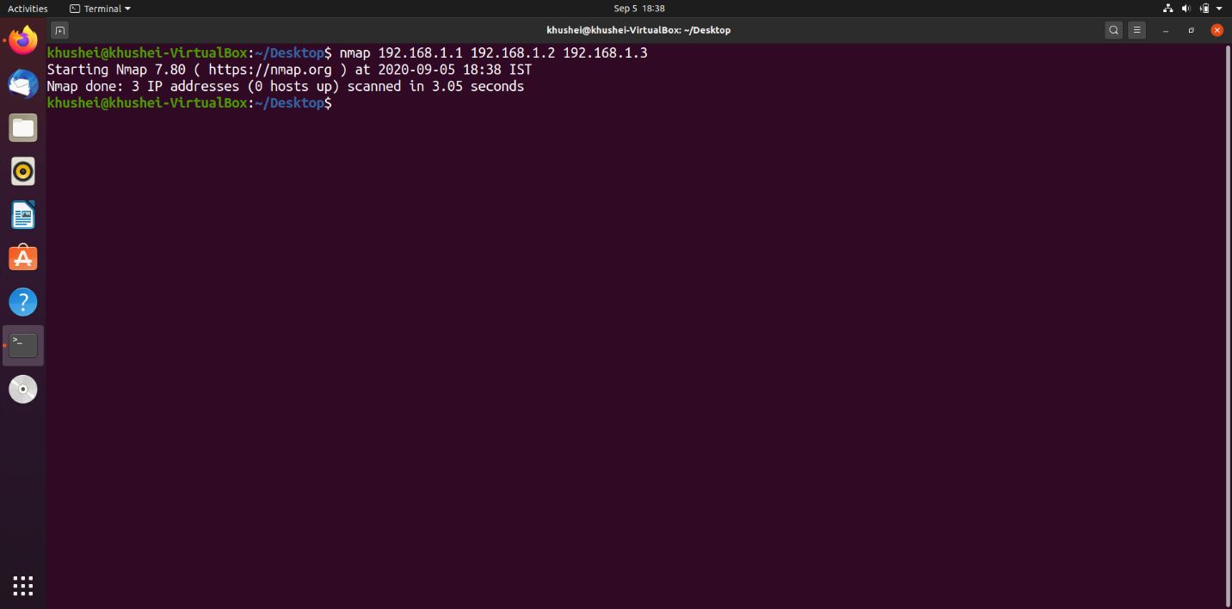

**Questions on above observations:**

1) Is your browser running HTTP version 1.0 or 1.1? What version of HTTP is the server?

Browser: HTTP version 1.1

Server: HTTP version 1.1

2) When was the HTML file that you are retrieving last modified at the server?

In task 3, we had followed TCP stream for the packet containing “GET / HTTP / 1.1”.

In that screenshot, we can see the Last-Modified field. It is Mon, 15 May 2017 18:04:40 GMT in my case.



3) How to tell ping to exit after a specified number of ECHO_REQUEST packets?

By using the -c flag with ping command.

ping -c <number_of_packets> <hostname>

4) How will you identify remote host apps and OS?

This can be done using nmap:

1) nmap -O -v localhost

2) nmap -O -v server.ip.address